**Milestone One Concept Memo**

**Team Nocturnal KnockTurtle**

Jackie Floyd, Sam Pollinger, Ria Shroff, Andrew Travis, Maeve Tucker, Shiyan Yang

**Vibrating Alarm Clock  
IED Section**: 08  
**Date**: 3/8/17

# **Introduction**

Moving into college and sharing a room with someone is a new and exciting experience for many college students. While having a companion can be enjoyable, suddenly there are a myriad of new potentially conflicts. One major one is dealing with the different sleep schedule of the other half of the room; two alarm clocks with different times and shrill tones are set up in one small room. This team aims to ease this tension between roommates and individuals sharing a bed with conflicting schedules to improve the health and happiness of both parties. This report outlines our progress thus far in developing a better wake up system from our initial problem statement, research and brainstorming, through our proposed solution and timeline for creating the prototype.

**Problem Statement**

Sleep is a precious commodity. Of 65,000 adults surveyed, two-thirds suffered from social jet lag—the chronic clash between what the body needs (sleep) and what social norms dictate (being on time)—meaning that they experienced at least a one hour difference between how long they slept on weekdays and weekends [2]. This is especially true for college students that regularly skimp on sleep to study for classes. A gallup poll shown in Figure 1 showed that younger individuals got less than seven hours of sleep more regularly than older individuals, and in Figure 2 that over time, people have overall been going to bed later, even though they were waking up at the same time [4]. With the pervasive lack of sleep that plagues our society comes a plethora of health issues like obesity, high blood pressure, and heart disease [2].

Figure 1: Reported Number of Hours Sleep, by Subgroup [4]

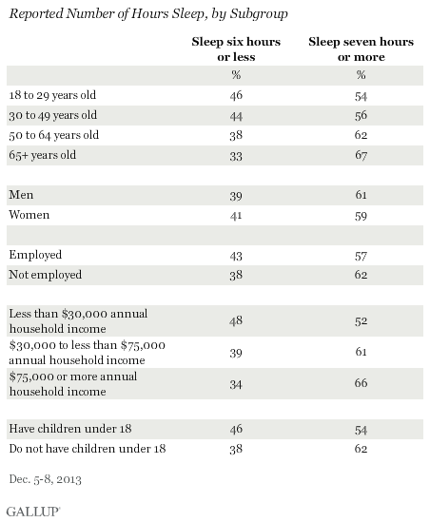

Figure 2: Reported Number of Hours Sleep Over Time [4]

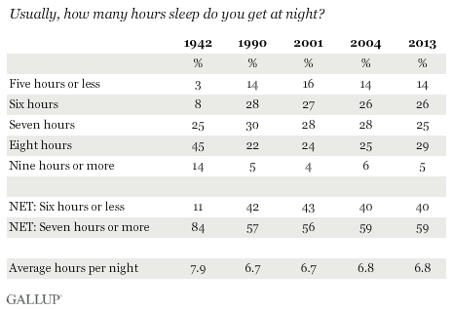

To stay healthy, individuals must do everything in their capacity to sleep as much as possible. However, in addition to an individual’s schedule and ability to make it to bed, there is the external factor of noises that are created around the individual. Many of these are not controllable, like a car alarm going off in the middle of the night, or a low-level earthquake. One recurring source of noise and disturbance is the roommate. In college, most students experience sharing a room with other individuals, and with that the struggle of coordinating sleep schedules. This also rings true for young adults sharing apartments after college, and couples cohabitating.

With two people in a small room waking up at different times and two alarm clocks in play, the roommates struggle to wake up only at their will, and not disturb their roommate. In a survey we conducted we found that 35% of the responders would not mind spending up to $20 to buy a quiet alarm clock that respects the needs of their roommate. The additional results of the survey can be seen in the Appendix of this memo.

This group aims to create an alarm clock that will wake an individual up without disturbing others in their vicinity in a way that is as effective in waking up the individual as their current method so that individuals can be more respectful of the sleep patterns of those with whom they share rooms. This wake up system will also have the secondary benefit of being a healthier wake-up system for the individual. A study by the National Institute of Industrial Health showed that suddenly force awakening participants led to higher blood pressure and heart rates in those individuals compared to those that woke up on their own [3]. This forced awakening triggered a low level flight-or-flight response in the individual, making the act of waking up a chronic stressor. A gentler alarm system that does not aggressively announce itself to the individual can serve to reduce that stress. This is also important for the roommate, because although they may wake up due to movements in the room as the individual gets ready, the ambient noises responsible for that kind of wake up are much easier for the body to recover from.

# **Customer Requirements**

The target customers for our vibrating alarm clock are primarily college students. In the future, our product could also prove to be useful for partners sharing a bed and those who are hearing impaired; however, the focus of this first model will on the student consumers because as college students ourselves, we have access to a large enough sample population to adequately test the prototype*.* College students also serve as a model audience as many share rooms and thus have experienced the problem of waking up or being woken up by others with alarm clocks. With this target audience in mind, we created and shared a survey, the same which is referenced in the problem definition section, asking about sleep and waking habits. The poll was circulated through college (primarily RPI) students. We used the survey responses to create a model of our typical consumer.

We found that of the applicable responses, 44.5% of people reported commonly being woken by someone else’s alarm, showing that this target audience would benefit from our product. Figure 3 shows the responses of levels of movement during the night. Most reported moving a moderate amount (defined on the survey as rolling over a few times) during the night. This wastaken into consideration when developing ideas for placement of the alarm system. Due to the small percentages of participants who reported excessive movement during the night, we have chosen to exclude this group from our audience and instead focus on the more average responses. Similarly, we chose to exclude very light or very heavy sleepers. Figure 4 shows the majority of respondents were between 3 and 8 on a scale from 1 to 10 with 1 being extremely easily.

Figure 3: Nightly Activity

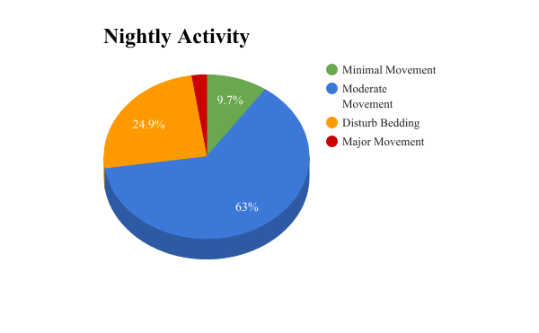

Figure 4: How Easily Are You Woken Up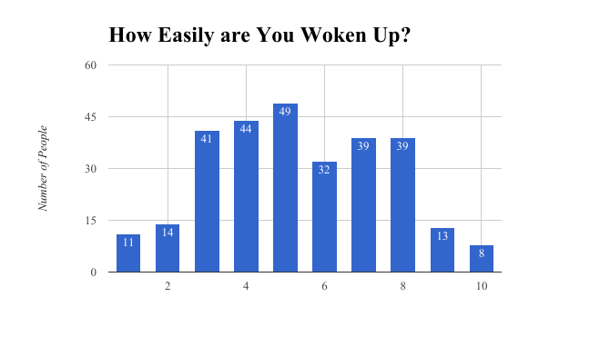

We also found that most of the respondents use a fitted sheet on their bed. The survey, as well as interviewing other students, allowed us to create a list of customer requirements. These needs are shown in Figure 5: Customer Requirements and Technical Specifications, which also includes applicable guidelines defined by the *IED Team Project Description*. These customer needs were simplified and prioritized in Figure 6: Prioritized Requirements.

Figure 5: Customer Requirements and Technical Specifications

|  |  |  |
| --- | --- | --- |
| **Customer Requirement** | **Technical Specification** | **Target Value / Range of Values** |
| Doesn’t hurt users | Safety | 0 casualties |
| Low risk of shock | Percent chance of getting shocked | *0.05%* |
| Large enough to ensure feeling | Pad Size | 1-2.5 feet wide 2-3 feet long |
| Easy to operate | Age | ~10+ years |
| *Durable* | *Stress*  *Water Resistant* |  |
| *Reliable* | *AC power with battery backup* | *No lithium batteries* |
| Wakes you up | Strength of vibrations, speakers  Effective system | *How Measured*?  30-50 dB alarm  *<5% sleep through it?* |
| Cost effective | Price more than standard alarm clock | <$30 |
| Pleasant to wake to | Gradual alarm system | 2-3 stages of vibration  Alarm sound option |
| Minimal discomfort | Thickness of pad | <2 inches at any point |
| Easy to read | Screen size | >1x2 inches |
| Hard to accidentally turn off | Location of buttons | 0 controls on pad |
| Won’t wake everyone | Low noise level | <40 dB |
| Fall asleep with noise | White noise timer | ~20 dB  ~20 minutes |

Figure 6: Prioritized Requirements

|  |  |
| --- | --- |
| **Need** | **Importance (1 being the most)** |
| Safety | 1 |
| Comfort | 4 |
| Cost | 5 |
| Wakes Only User | 2 |
| Reliable | 3 |

# **Concepts and Benchmarking**

When considering the problem we defined, we began by considering the many ways to wake a person up. We created a mind map, shown below in Figure 7, to evaluate all of these options. The different ways we came up with included an alarm sound, light, vibration, bed shaking, a temperature change, and removing blankets.

Figure 7: Mind Map

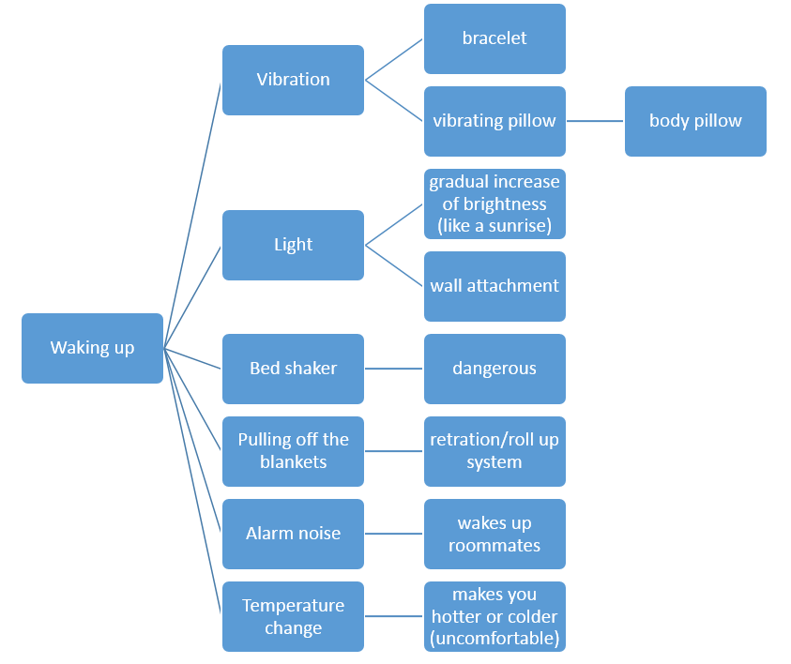

To determine which option was best for our project, we used a concept selection matrix, which can be seen below in Figure 8. The categories that we decided to evaluate were how effective each system would be in waking up the user, how safe the system was, whether or not it would disturb a user’s roommate, and how pleasant the system would be to wake up to. We decided that all of the systems would be effective in waking the user up, except for the light and pulling the blankets off. This is because a large number of people toss and turn during the night so they could end up facing away from the light, and they could also throw off their blankets in their sleep. Bed shaking could be unsafe because depending on how aggressive it was, the user could fall off. The temperature change could also be unsafe due to requiring heating elements to be placed under bedding. An alarm sound, possibly light, and bed shaking could disturb the user’s roommate, which goes against our problem statement. After considering all of the categories, it was clear that vibration was the best option for our group to focus on.

Figure 8: Concept selection matrix

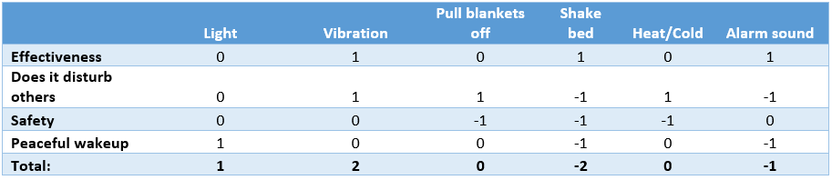

We did research to find out what other vibrating alarm systems existed. We found a few products that allowed the user to put the device under their pillow and it would vibrate to wake them up [1],[5],[7]. Some of these connected to your phone via Bluetooth to set the alarm, and some had the alarm controls on the device. Another device that went under the user’s pillow was wired to a normal alarm clock. This product is called the Sonic Bomb Alarm clock, and is pictured in Figure 9 [8]. We liked how this product was wired so the user does not have to rely on Bluetooth or batteries, but the “sonic bomb” alarm sound that accompanies the vibration would wake everyone else in the room, so it did not solve our initial problem. We read online reviews of this product and also found that many customers who have used it found the vibrations to be weak and hard to feel under the pillow.

Figure 9: Sonic Bomb Alarm [8]

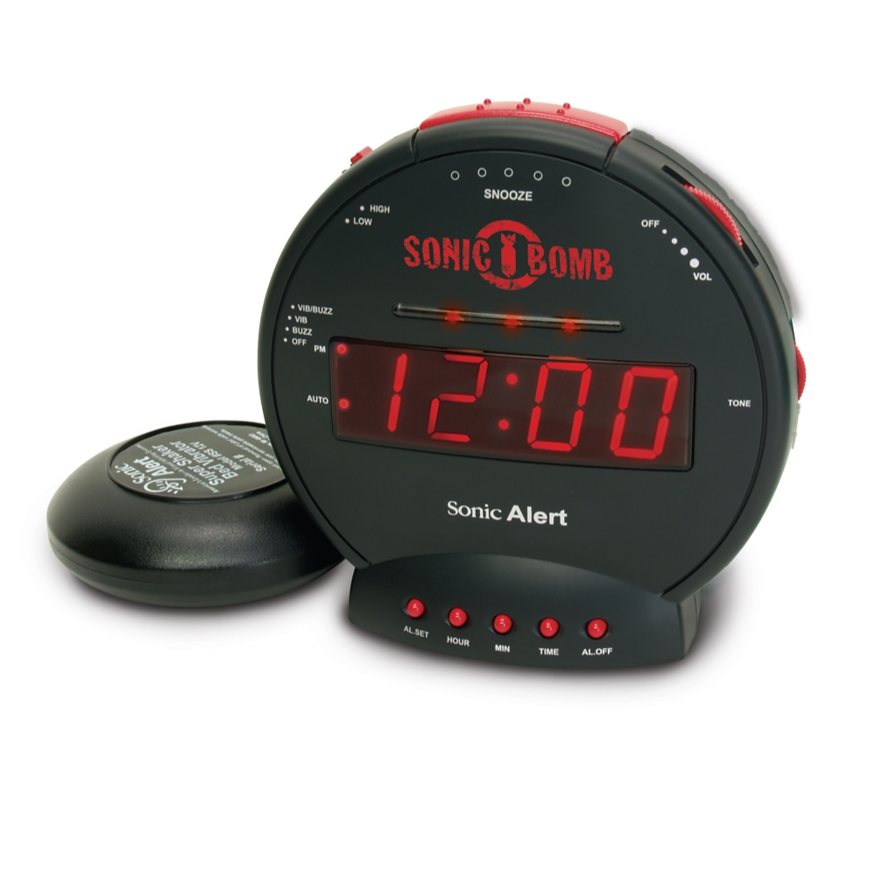

We also had the idea of a wearable device that would vibrate to wake the user. There is an existing product like this, called the Shake-n-Wake, shown in Figure 10 [6]. By having the alarm controls on the device on the wrist, we were worried that the user could accidentally turn off or alter their alarm settings in their sleep. In addition, we feel it would be uncomfortable to sleep with the plastic alarm on your wrist.

Figure 10: Shake-n-Wake alarm [6]

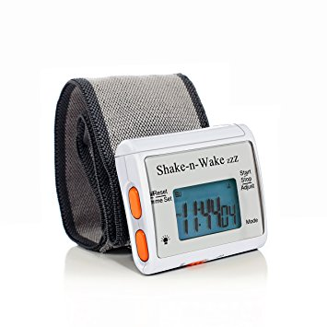

Through brainstorming we determined that we would use vibrations to wake up our users. We want to make sure our alarm is effective at waking the user and can not be knocked out of place or off the bed, and is comfortable to use. Benchmarking showed us what was already on the market. We pulled concepts from the products we found that worked well, and used reviews to determine what about features of those products we did not want to use and what we could improve upon. To give our product and extra selling point, we decided to add an extra feature. Because our customer research showed that many people in our customer demographic use the sound of a fan or some other while noise to fall asleep, we want to include that in some way to make our product useful for both falling asleep and waking up.

**Proposed Solution**

In order to solve the issue of having the user’s alarm wake others up, we decided to implement a design that incorporated vibration as the main method of waking its user up. The use of vibration as the main method allows for there to be minimal audible noise associated with the alarm going off. To implement this idea, we decided to put small vibrating motors into a pad which will be placed underneath a fitted sheet. This pad will be hardwired to the external alarm casing, as seen in Figure 11, allowing us to exclude any possible failures that could occur with either bluetooth or a wireless connection.

As can also be seen in Figure 11, the vibrating motors will also be accompanied by speakers. These speakers will act as a failsafe if the user has not already woken up and will go off after a set amount time after the initial vibration started. The speakers will also provide the user with the option of playing white noise to help fall asleep.

The system will have its main power source be a standard wall outlet and have a backup battery support incase there is power outage. The backup battery system will be supported by a 9 volt battery and have an access panel on the back side of the alarm casing to give the user easy access to replace the backup battery. The decision to make the main power source a standard wall outlet was based on the fact that it is a more reliable source of power when compared to batteries that are capable of dying without the using being aware of it.

In order to give each feature of the clock proper attention, the project has been broken down into seven subsystems that can be seen in Figure 12.

Figure 11: Concept design

Figure 12: Subsystems

|  |  |  |
| --- | --- | --- |
| **Subsystem** | **Owner** | **Description** |
| Alarm Casing | Andrew Travis | Building the physical casing to house all of the internal components of the alarm clock. |
| Vibration | Jackie Floyd | Creating a vibrating apparatus that easily and effectively distributes vibration to maximize vibrating power. |
| Speakers | Maeve Tucker | Making sure that the speakers are housed in such a way that the user will not break them through normal use. |
| Safety | Sam Pollinger | Making sure that the whole system is up to code with state regulations and does not present a threat to the user’s well being. |
| Wiring and Power | Shiyan Yang | Wiring the main power supply and the backup battery and making sure that all of the components receive adequate power. |
| Electrical Components | Ria Shroff | Assembling of electronic components including soldering and attaching all components in the right way. |
| Programming | Outsourced/Shared | Programming of alarm clock to have all components interface as desired. |

# **Project Plan**

The Gantt chart, shown in in Figure 13, outlines the rough estimate of our project plan. Task completion dates are based on assigned due dates. While many areas show single ownership, most tasks will be cooperative efforts, especially testing, presentations and reports.

Figure 13: Gantt chart

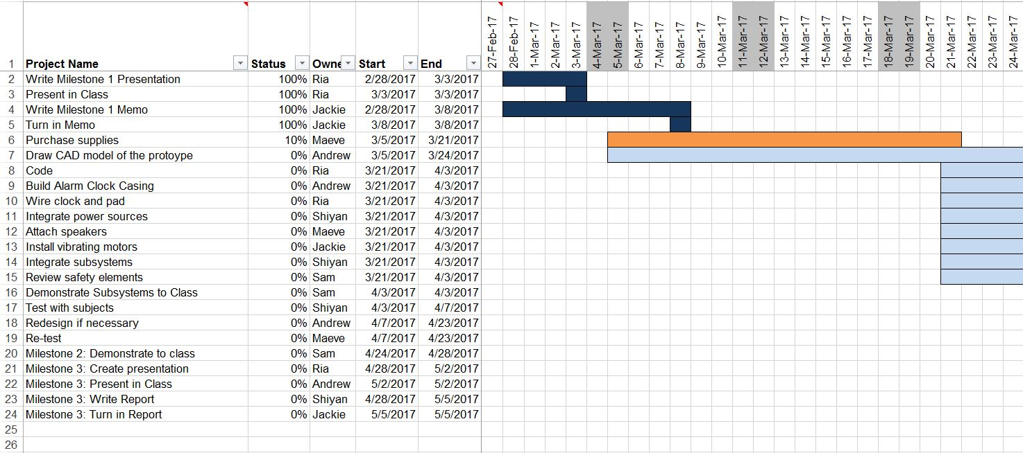

# **Materials**

The parts list shown in Figure 14 was created to estimate how much the group would have to spend as well as organize what materials we would have to acquire and where we would get them from.

Figure 14: Parts list

|  |  |  |
| --- | --- | --- |
| **Part** | **Where to purchase** | **Estimated price ($)** |
| Vibrating motors (6) | Sparkfun | 35 |
| Arduino UNO | Arduino | 25 |
| Clock module | Amazon | 15 |
| Speaker | TBD | 10 |
| Potentiometer | TBD | 5 |
| Alarm clock (for parts) | Walmart | 6 |
| Power cord | Scrap from existing alarm clock | 0 |
| Power converter | Scrap from existing alarm clock | 0 |
| Resistors | Andrew has | 0 |
| Wires | Scrap from existing alarm clock | 0 |
| LCD screen | Scrap from existing alarm clock | 0 |
| Material for alarm casing | Scrap material/wood | 0 |
| Material for pad casing | JoAnn’s Fabric | TBD |
| Breadboard | TBD | TBD |
| **TOTAL COST:** |  | $96 |

# **Conclusion**

People in shared living spaces must coordinate many of their activities when in the room together, however, they can’t help needing alarms to wake up. The survey received many responses, not only defining the target customer, but also showing that approximately half the college students from the sample have the issue of being woken up by their roommates. This data gives value to our project; success in this project can be helpful in improving students’ relationships and health in the long term. After benchmarking, we found that none of the other similar existing products properly addressed our specific issue of creating a silent alarm clock which would not wake up others in the same room. Our alarm clock will provide a quiet and comfortable experience for both customers and their roommates.

**References**

[1]"Amplifyze TCL Pulse", Harriscomm.com, 2017. [Online]. Available: http://www.harriscomm.com/amplifyze-tcl-pulse-pink-bluetooth-vibrating-bed-shaker-and-sound-alarm-by-amplicom.html. [Accessed: 20- Feb- 2017].

[2]C. Kalb, "Your Alarm Clock May Be Hazardous to Your Health", Smithsonian Magazine, 2013. [Online]. Available: http://www.smithsonianmag.com/science-nature/your-alarm-clock-may-be-hazardous-to-your-health-164620290/#hKLsFYFf0wiaDyWb.99. [Accessed: 05- Mar- 2017].

[3]"Is your alarm clock bad for your health?", Sites.psu.edu, 2015. [Online]. Available: https://sites.psu.edu/siowfa15/2015/09/16/is-your-alarm-clock-bad-for-your-health/. [Accessed: 06- Mar- 2017].

[4]J. Jones, "In U.S., 40% Get Less Than Recommended Amount of Sleep", Gallup, 2017. [Online]. Available: http://www.gallup.com/poll/166553/less-recommended-amount-sleep.aspx. [Accessed: 06- Mar- 2017].

[5]"Sharp Vibrating Pillow Alarm Clock", Amazon.com, 2017. [Online]. Available: https://www.amazon.com/Sharp-Vibrating-Pillow-Alarm-Clock/dp/B00N33YR1O. [Accessed: 20- Feb- 2017].

[6]"Silent Vibrating Personal Alarm Clock "Shake-N-Wake"", *Amazon.com*. [Online]. Available: https://www.amazon.com/Silent-Vibrating-Personal-Alarm-Shake-N-Wake/dp/B0027A573Q. [Accessed: 20- Feb- 2017].

[7]"Smart Shake", *Hearmore.com*, 2017. [Online]. Available: http://www.hearmore.com/store/prodView.asp?idproduct=15724&idstore=6&product=Smart-Shaker---White. [Accessed: 20- Feb- 2017].

[8]"Sonic Bomb Loud Dual Alarm Clock", *Amazon.com*, 2017. [Online]. Available: https://www.amazon.com/Sonic-Alert-SBB500SS-Alarm-Shaker/dp/B000OOWZUK/ref=pd_bxgy_201_img_2?_encoding=UTF8&pd_rd_i=B000OOWZUK&pd_rd_r=BTDEPJCZ45ENKX4G36WE&pd_rd_w=Jlr4g&pd_rd_wg=fuDiL&psc=1&refRID=BTDEPJCZ45ENKX4G36WE. [Accessed: 20- Feb- 2017].

**Appendix A**  
